SEC Form 4

FORM 4

Check this box if no longer subject to Section 16. Form 4 or Form 5 obligations may continue. See Instruction 1(b).

UNITED STATES SECURITIES AND EXCHANGE COMMISSION
Washington, D.C. 20549
 |  | OMB APPROVAL
STATEMENT OF CHANGES IN BENEFICIAL OWNERSHIP
 |  | OMB Number: | 3235-0287
 |  | Estimated average burden
Filed pursuant to Section 16(a) of the Securities Exchange Act of 1934 |  | hours per response: | 0.5
or Section 30(h) of the Investment Company Act of 1940
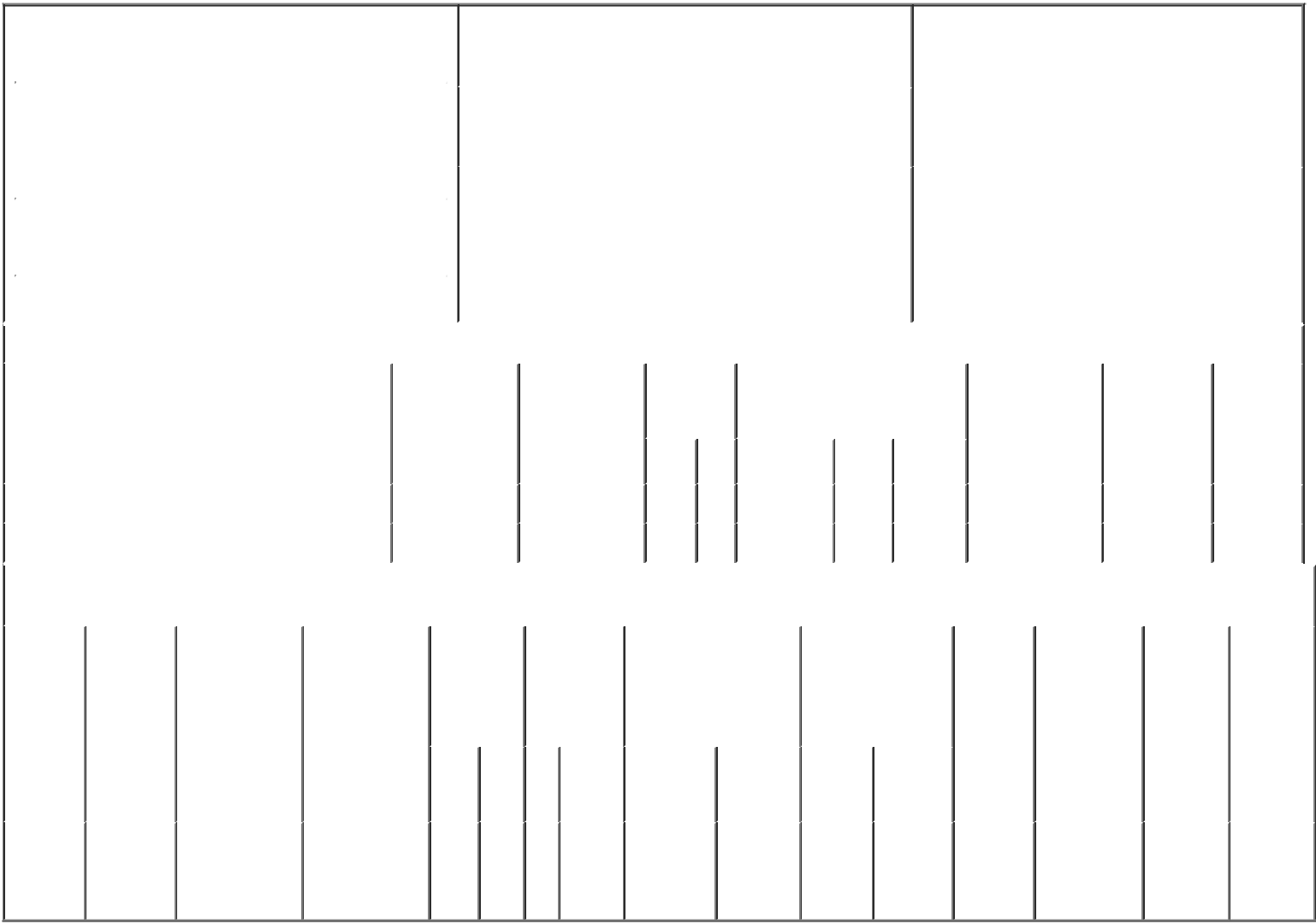

 | 1. Name and Address of Reporting Person* |  |  |  |  |  |  |  |  | 2. Issuer Name and Ticker or Trading Symbol |  |  |  |  |  |  |  |  |  | 5. Relationship of Reporting Person(s) to Issuer
 |  | WILLIAMSON JOHN B III |  |  |  |  |  |  |  | LUNA INNOVATIONS INC [ LUNA ] |  |  |  |  |  |  |  |  |  | (Check all applicable)
 |  |  |  |  |  |  |  |  |  |  |  |  |  |  |  |  |  |  |  | X |  |  | Director |  |  | 10% Owner
 |  |  |  |  |  |  |  |  |  |  |  |  |  |  |  |  |  |  |  |  |  |  | Officer (give title |  |  | Other (specify
 |  |  |  |  |  |  |  |  |  | 3. Date of Earliest Transaction (Month/Day/Year)
 |  | (Last) |  | (First) |  |  | (Middle) |  |  |  |  |  |  |  |  |  |  |  |  |  |  |  | below) |  |  | below)
 |  |  |  |  |  |  |  | 01/08/2020
 |  | C/O LUNA INNOVATIONS INCORPORATED
 |  | 301 1ST STREET SW, SUITE 200
 |  |  |  |  |  |  |  |  |  | 4. If Amendment, Date of Original Filed (Month/Day/Year) |  |  |  |  |  |  |  |  |  | 6. Individual or Joint/Group Filing (Check Applicable
 |  |  |  |  |  |  |  |  |  |  |  |  |  |  |  |  |  |  |  | Line)
 | (Street) |  |  |  |  |  |  |  |  |  |  |  |  |  |  |  |  |  |  | X |  |  | Form filed by One Reporting Person
 |  | ROANOKE |  | VA |  |  | 24011 |  |  |  |  |  |  |  |  |  |  |  |  |  |  |  | Form filed by More than One Reporting
 |  |  |  |  |  |  |  |  |  |  |  |  |  |  |  |  |  |  |  |  |  |  | Person
 |  | (City) |  | (State) |  |  | (Zip)
 |  |  |  |  | Table I - Non-Derivative Securities Acquired, Disposed of, or Beneficially Owned
 | 1. Title of Security (Instr. 3) |  |  |  |  |  | 2. Transaction |  |  |  |  | 2A. Deemed | 3. |  | 4. Securities Acquired (A) or |  |  |  |  |  |  |  | 5. Amount of |  | 6. Ownership |  | 7. Nature of
 |  |  |  |  |  |  | Date |  |  |  |  | Execution Date, |  | Transaction Disposed Of (D) (Instr. 3, 4 and 5) |  |  |  |  |  |  |  |  | Securities |  | Form: Direct |  | Indirect
 |  |  |  |  |  |  | (Month/Day/Year) |  |  |  |  | if any |  | Code (Instr. |  |  |  |  |  |  |  |  | Beneficially |  | (D) or Indirect |  | Beneficial
 |  |  |  |  |  |  |  |  |  |  |  | (Month/Day/Year) 8) |  |  |  |  |  |  |  |  |  |  | Owned Following |  | (I) (Instr. 4) |  | Ownership
 |  |  |  |  |  |  |  |  |  |  |  |  |  |  |  |  |  |  |  |  |  |  | Reported |  |  |  | (Instr. 4)
 |  |  |  |  |  |  |  |  |  |  |  |  |  | Code V | Amount |  |  | (A) or | Price |  |  |  | Transaction(s)
 |  |  |  |  |  |  |  |  |  |  |  |  |  |  |  |  |  | (D) |  |  |  |  | (Instr. 3 and 4)
 | Common Stock |  |  |  |  |  | 01/08/2020 |  |  |  |  |  |  | M | 120,000 |  |  | A | $4.43 |  |  | 278,176 |  |  |  | D
 | Common Stock |  |  |  |  |  | 01/08/2020 |  |  |  |  |  |  | _{F}(1) | 20,000 |  |  | D | $7.56 |  |  | 258,176 |  |  |  | D
 |  |  |  |  |  |  | Table II - Derivative Securities Acquired, Disposed of, or Beneficially Owned
 |  |  |  |  |  |  | (e.g., puts, calls, warrants, options, convertible securities)
 | 1. Title of |  | 2. |  | 3. Transaction |  | 3A. Deemed | 4. |  |  |  | 5. Number of | 6. Date Exercisable and |  |  |  | 7. Title and Amount |  |  |  |  | 8. Price of |  | 9. Number of |  | 10. | 11. Nature
 | Derivative |  | Conversion |  | Date |  | Execution Date, | Transaction |  |  |  | Derivative | Expiration Date |  |  |  | of Securities |  |  |  |  | Derivative |  | derivative |  | Ownership of Indirect
 | Security |  | or Exercise |  | (Month/Day/Year) |  | if any | Code (Instr. |  |  |  | Securities | (Month/Day/Year) |  |  |  | Underlying |  |  |  |  | Security |  | Securities |  | Form: | Beneficial
 | (Instr. 3) |  | Price of |  |  |  | (Month/Day/Year) | 8) |  |  |  | Acquired (A) |  |  |  |  | Derivative Security |  |  |  |  | (Instr. 5) |  | Beneficially |  | Direct (D) | Ownership
 |  |  | Derivative |  |  |  |  |  |  |  |  | or Disposed |  |  |  |  | (Instr. 3 and 4) |  |  |  |  |  |  | Owned |  | or Indirect | (Instr. 4)
 |  |  | Security |  |  |  |  |  |  |  |  | of (D) (Instr. |  |  |  |  |  |  |  |  |  |  |  | Following |  | (I) (Instr. 4)
 |  |  |  |  |  |  |  |  |  |  |  | 3, 4 and 5) |  |  |  |  |  |  |  |  |  |  |  | Reported
 |  |  |  |  |  |  |  |  |  |  |  |  |  |  |  |  |  |  |  |  |  |  |  | Transaction(s)
 |  |  |  |  |  |  |  |  |  |  |  |  |  |  |  |  |  |  | Amount |  |  |  |  | (Instr. 4)
 |  |  |  |  |  |  |  |  |  |  |  |  |  |  |  |  |  |  | or
 |  |  |  |  |  |  |  |  |  |  |  |  | Date |  | Expiration |  |  |  | Number
 |  |  |  |  |  |  |  | Code V |  |  |  | (A) (D) | Exercisable |  | Date |  | Title |  | of Shares
 | Common
 | Stock |  |  |  |  |  |  |  |  |  |  |  |  |  |  |  | Common |  | 120,000
 | Option |  | $4.43 |  | 01/08/2020 |  |  |  | M |  |  | 120,000 | 01/12/2013 |  | 01/12/2020 |  |  |  |  |  |  | $0 |  | 0 |  | D
 | (Right to |  |  |  |  |  |  |  |  |  |  |  |  |  |  |  | Stock
Buy)

Explanation of Responses:

1. These shares were delivered to the Issuer for the sole purpose of paying a portion of the exercise price of the option reported on Table II of this form.

Remarks:
/s/ Scott A. Graeff, Attorney-In- _{01/10/2020}
Fact

** Signature of Reporting Person Date

Reminder: Report on a separate line for each class of securities beneficially owned directly or indirectly.

* If the form is filed by more than one reporting person, see Instruction 4 (b)(v).

- Intentional misstatements or omissions of facts constitute Federal Criminal Violations See 18 U.S.C. 1001 and 15 U.S.C. 78ff(a). Note: File three copies of this Form, one of which must be manually signed. If space is insufficient, see Instruction 6 for procedure.

Persons who respond to the collection of information contained in this form are not required to respond unless the form displays a currently valid OMB Number.

