SEC Form 4

FORM 4

Check this box if no longer subject to Section 16. Form 4 or Form 5 obligations may continue. See Instruction 1(b).

UNITED STATES SECURITIES AND EXCHANGE COMMISSION
Washington, D.C. 20549
 |  | OMB APPROVAL
STATEMENT OF CHANGES IN BENEFICIAL OWNERSHIP
 |  | OMB Number: | 3235-0287
 |  | Estimated average burden
Filed pursuant to Section 16(a) of the Securities Exchange Act of 1934 |  | hours per response: | 0.5
or Section 30(h) of the Investment Company Act of 1940
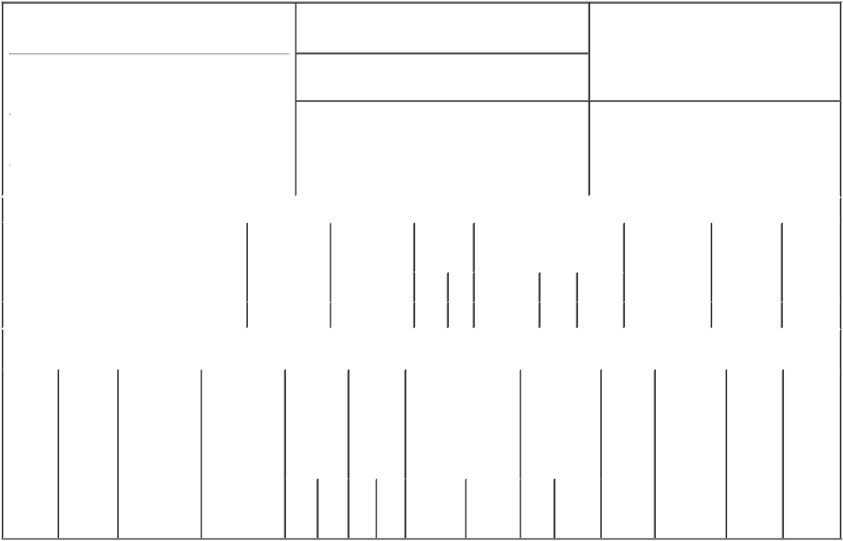

1. Name and Address of Reporting Person*
Pastor Donald

(Last) (First) (Middle)

301 1ST STREET, SW, SUITE 200

2. Issuer Name and Ticker or Trading Symbol

LUNA INNOVATIONS INC [ LUNA ]

3. Date of Earliest Transaction (Month/Day/Year)
05/15/2018

- Relationship of Reporting Person(s) to Issuer (Check all applicable)
X Director 10% Owner

Officer (give title Other (specify
below) below)

 |  |  |  |  |  |  |  | 4. If Amendment, Date of Original Filed (Month/Day/Year) |  |  |  |  |  |  |  | 6. Individual or Joint/Group Filing (Check Applicable
 | (Street) |  |  |  |  |  |  | 05/17/2018 |  |  |  |  |  |  |  | Line)
 |  |  |  |  |  |  |  |  |  |  |  |  |  |  |  |  |  | X Form filed by One Reporting Person
 |  | ROANOKE |  | VA |  | 24011
 |  |  |  |  |  |  |  |  |  |  |  |  |  |  |  |  |  |  | Form filed by More than One Reporting
 |  |  |  |  |  |  |  |  |  |  |  |  |  |  |  |  |  |  | Person
 |  | (City) |  | (State) |  | (Zip)
 |  |  |  |  | Table I - Non-Derivative Securities Acquired, Disposed of, or Beneficially Owned
 | 1. Title of Security (Instr. 3) |  |  |  |  | 2. Transaction |  |  | 2A. Deemed |  | 3. |  | 4. Securities Acquired (A) or |  |  |  |  |  | 5. Amount of |  | 6. Ownership | 7. Nature
 |  |  |  |  |  | Date |  |  | Execution Date, |  |  | Transaction | Disposed Of (D) (Instr. 3, 4 and |  |  |  |  |  | Securities |  | Form: Direct | of Indirect
 |  |  |  |  |  | (Month/Day/Year) |  |  | if any |  |  | Code (Instr. | 5) |  |  |  |  |  | Beneficially |  | (D) or Indirect | Beneficial
 |  |  |  |  |  |  |  |  | (Month/Day/Year) |  | 8) |  |  |  |  |  |  |  | Owned Following |  | (I) (Instr. 4) | Ownership
 |  |  |  |  |  |  |  |  |  |  |  |  |  |  |  |  |  |  | Reported |  |  | (Instr. 4)
 |  |  |  |  |  |  |  |  |  |  |  | Code V | Amount |  | (A) or | Price |  |  | Transaction(s)
 |  |  |  |  |  |  |  |  |  |  |  |  |  |  | (D) |  |  |  | (Instr. 3 and 4)
 | Common Stock⁽¹⁾ |  |  |  |  | 05/15/2018 |  |  |  |  |  | A | _{8,143}(2)(3) |  | A | $0 |  | 130,434 |  |  | D
 |  |  |  |  | Table II - Derivative Securities Acquired, Disposed of, or Beneficially Owned
 |  |  |  |  |  | (e.g., puts, calls, warrants, options, convertible securities)
 | 1. Title of |  | 2. |  | 3. Transaction | 3A. Deemed |  | 4. |  | 5. Number | 6. Date Exercisable and |  |  | 7. Title and |  |  | 8. Price of |  |  | 9. Number of | 10. | 11. Nature
 | Derivative |  | Conversion |  | Date | Execution Date, |  | Transaction |  | of | Expiration Date |  |  | Amount of |  |  | Derivative |  |  | derivative | Ownership | of Indirect
 | Security |  | or Exercise |  | (Month/Day/Year) | if any |  | Code (Instr. |  | Derivative | (Month/Day/Year) |  |  | Securities |  |  | Security |  |  | Securities | Form: | Beneficial
 | (Instr. 3) |  | Price of |  |  | (Month/Day/Year) |  | 8) |  | Securities |  |  |  | Underlying |  |  | (Instr. 5) |  |  | Beneficially | Direct (D) | Ownership
 |  |  | Derivative |  |  |  |  |  |  | Acquired |  |  |  | Derivative |  |  |  |  |  | Owned | or Indirect | (Instr. 4)
 |  |  | Security |  |  |  |  |  |  | (A) or |  |  |  | Security (Instr. 3 |  |  |  |  |  | Following | (I) (Instr. 4)
 |  |  |  |  |  |  |  |  |  | Disposed |  |  |  | and 4) |  |  |  |  |  | Reported
 |  |  |  |  |  |  |  |  |  | of (D) |  |  |  |  |  |  |  |  |  | Transaction(s)
 |  |  |  |  |  |  |  |  |  | (Instr. 3, 4 |  |  |  |  |  |  |  |  |  | (Instr. 4)
 |  |  |  |  |  |  |  |  |  | and 5)
 |  |  |  |  |  |  |  |  |  |  |  |  |  |  | Amount
 |  |  |  |  |  |  |  |  |  |  |  |  |  |  | or
 |  |  |  |  |  |  |  |  |  |  |  |  |  |  | Number
 |  |  |  |  |  |  |  |  |  |  | Date |  | Expiration |  | of
 |  |  |  |  |  |  |  | Code V |  | (A) (D) | Exercisable |  | Date | Title | Shares

Explanation of Responses:

- Consists of restricted stock units that are convertible into issuer's common stock on a 1-for-1 basis.

- This grant was awarded in connection with Mr. Pastor's service as a member of the board of directors, pursuant to the issuer's non-employee director compensation policy. The number of stock units awarded is equal to $25,000 divided by $3.07, the closing price of the issuer's stock on Nasdaq Capital Market on May 15, 2018, the date of grant.

- The stock units will vest fully on the earlier of the one year anniversary of date or the next annual meeting of stockholders.

Remarks:

This amended report is being filed to report the grant of restricted stock units in Table I, rather than Table II as originally reported, and to clarify that the delivery of shares upon vesting of the award has not been deferred pursuant to the Issuer's non-employee director deferred compensation plan.

/s/ Scott A. Graeff, Attorney- |  |  | 07/03/2018
In-Fact
** Signature of Reporting Person |  |  | Date

Reminder: Report on a separate line for each class of securities beneficially owned directly or indirectly.

* If the form is filed by more than one reporting person, see Instruction 4 (b)(v).

- Intentional misstatements or omissions of facts constitute Federal Criminal Violations See 18 U.S.C. 1001 and 15 U.S.C. 78ff(a). Note: File three copies of this Form, one of which must be manually signed. If space is insufficient, see Instruction 6 for procedure.
Persons who respond to the collection of information contained in this form are not required to respond unless the form displays a currently valid OMB Number.

