SEC Form 4

FORM 4

Check this box if no longer subject to Section 16. Form 4 or Form 5 obligations may continue. See Instruction 1(b).

UNITED STATES SECURITIES AND EXCHANGE COMMISSION
Washington, D.C. 20549
 |  | OMB APPROVAL
STATEMENT OF CHANGES IN BENEFICIAL OWNERSHIP
 |  | OMB Number: | 3235-0287
 |  | Estimated average burden
Filed pursuant to Section 16(a) of the Securities Exchange Act of 1934 |  | hours per response: | 0.5
or Section 30(h) of the Investment Company Act of 1940
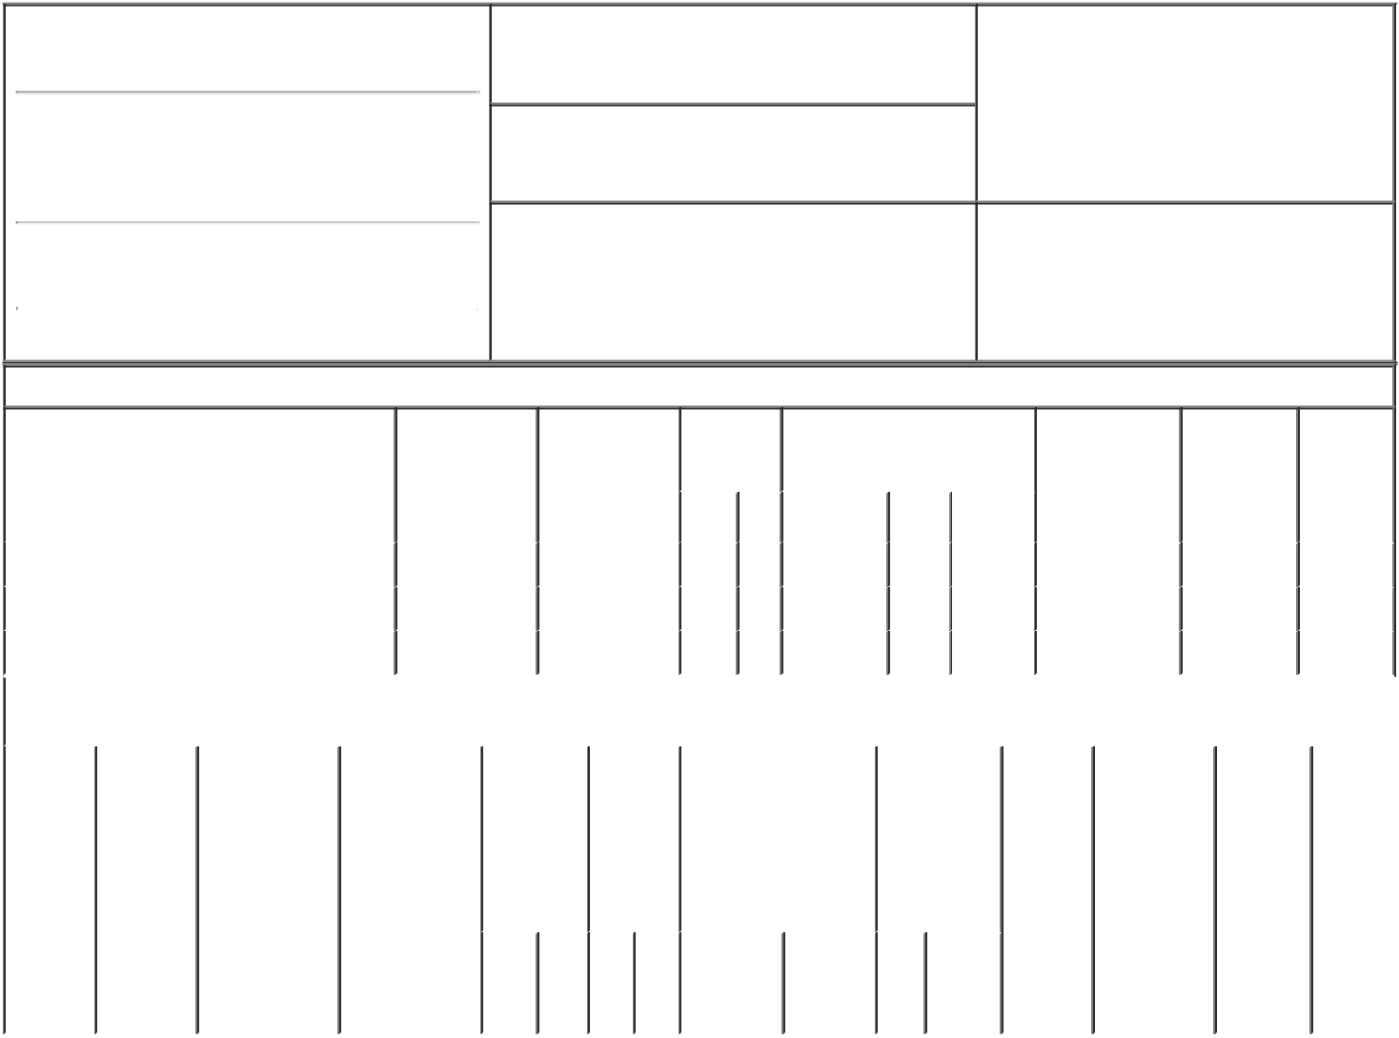

1. Name and Address of Reporting Person*
Graeff Scott A

(Last) (First) (Middle)

C/O LUNA INNOVATIONS INCORPORATED 301 1ST STREET, SW, SUITE 200

2. Issuer Name and Ticker or Trading Symbol

LUNA INNOVATIONS INC [ LUNA ]

3. Date of Earliest Transaction (Month/Day/Year)

01/06/2022

- Relationship of Reporting Person(s) to Issuer (Check all applicable)

X | Director | 10% Owner
X | Officer (give title | Other (specify
 | below) | below)

Chief Executive Officer

(Street)
 | ROANOKE | VA | 24011
 | (City) | (State) | (Zip)

4. If Amendment, Date of Original Filed (Month/Day/Year) 6. Individual or Joint/Group Filing (Check Applicable
Line)
X Form filed by One Reporting Person

Form filed by More than One Reporting
Person

Table I - Non-Derivative Securities Acquired, Disposed of, or Beneficially Owned

 | 1. Title of Security (Instr. 3) |  |  | 2. Transaction |  | 2A. Deemed |  | 3. | 4. Securities Acquired (A) or |  |  |  |  |  | 5. Amount of |  |  | 6. Ownership | 7. Nature
 |  |  |  | Date |  | Execution Date, |  | Transaction | Disposed Of (D) (Instr. 3, 4 and |  |  |  |  |  | Securities |  |  | Form: Direct | of Indirect
 |  |  |  | (Month/Day/Year) |  | if any |  | Code (Instr. | 5) |  |  |  |  |  | Beneficially |  |  | (D) or Indirect | Beneficial
 |  |  |  |  |  | (Month/Day/Year) |  | 8) |  |  |  |  |  |  | Owned Following |  |  | (I) (Instr. 4) | Ownership
 |  |  |  |  |  |  |  |  |  |  |  |  |  |  | Reported |  |  |  | (Instr. 4)
 |  |  |  |  |  |  |  | Code V | Amount | (A) or |  | Price |  |  | Transaction(s)
 |  |  |  |  |  |  |  |  |  | (D) |  |  |  |  | (Instr. 3 and 4)
 | Common Stock |  |  | 01/06/2022 |  |  |  | A | 54,910⁽¹⁾ | A |  | $0 |  |  |  | 609,934 |  | D
 | Common Stock |  |  | 01/07/2022 |  |  |  | F | 3,919⁽²⁾ | D |  | $7.48⁽³⁾ |  |  |  | 606,015 |  | D
 | Common Stock |  |  | 01/10/2022 |  |  |  | F | 7,622⁽²⁾ | D |  | $7.42⁽³⁾ |  |  |  | 598,393 |  | D
 |  |  | Table II - Derivative Securities Acquired, Disposed of, or Beneficially Owned
 |  |  |  | (e.g., puts, calls, warrants, options, convertible securities)
 | 1. Title of | 2. | 3. Transaction | 3A. Deemed | 4. |  | 5. Number | 6. Date Exercisable and |  | 7. Title and |  |  |  | 8. Price of |  |  | 9. Number of 10. |  | 11. Nature
 | Derivative | Conversion | Date | Execution Date, | Transaction |  | of | Expiration Date |  | Amount of |  |  |  | Derivative |  |  | derivative | Ownership | of Indirect
 | Security | or Exercise | (Month/Day/Year) | if any | Code (Instr. |  | Derivative | (Month/Day/Year) |  | Securities |  |  |  | Security |  |  | Securities | Form: | Beneficial
 | (Instr. 3) | Price of |  | (Month/Day/Year) | 8) |  | Securities |  |  | Underlying |  |  |  | (Instr. 5) |  |  | Beneficially | Direct (D) | Ownership
 |  | Derivative |  |  |  |  | Acquired |  |  | Derivative |  |  |  |  |  |  | Owned | or Indirect | (Instr. 4)
 |  | Security |  |  |  |  | (A) or |  |  | Security (Instr. |  |  |  |  |  |  | Following | (I) (Instr. 4)
 |  |  |  |  |  |  | Disposed |  |  | 3 and 4) |  |  |  |  |  |  | Reported
 |  |  |  |  |  |  | of (D) |  |  |  |  |  |  |  |  |  | Transaction(s)
 |  |  |  |  |  |  | (Instr. 3, 4 |  |  |  |  |  |  |  |  |  | (Instr. 4)
 |  |  |  |  |  |  | and 5)
 |  |  |  |  |  |  |  |  |  |  | Amount
 |  |  |  |  |  |  |  |  |  |  | or
 |  |  |  |  |  |  |  |  |  |  | Number
 |  |  |  |  |  |  |  | Date | Expiration |  | of
 |  |  |  |  | Code | V | (A) (D) | Exercisable | Date | Title | Shares

Explanation of Responses:

- Consists of restricted stock units. Each restricted stock unit represents the contingent right to receive one share of common stock of the Issuer. The restricted stock units vest in three equal annual installments from January 6, 2022, subject to the Reporting Person's continued service with the Company as of each vesting date.

- These shares were repurchased by the Issuer pursuant to the election of the holder to satisfy tax withholdings requirements with respect to the vesting of restricted stock awards.

- The price represents the closing sales price of the Issuer's common stock on the date of the election.

Remarks:

/s/ Scott A. Graeff |  |  | 01/10/2022
** Signature of Reporting Person |  | Date

Reminder: Report on a separate line for each class of securities beneficially owned directly or indirectly.

* If the form is filed by more than one reporting person, see Instruction 4 (b)(v).

- Intentional misstatements or omissions of facts constitute Federal Criminal Violations See 18 U.S.C. 1001 and 15 U.S.C. 78ff(a). Note: File three copies of this Form, one of which must be manually signed. If space is insufficient, see Instruction 6 for procedure.
Persons who respond to the collection of information contained in this form are not required to respond unless the form displays a currently valid OMB Number.

