SEC Form 4
FORM 4 |  | UNITED STATES SECURITIES AND EXCHANGE COMMISSION  Washington, D.C. 20549  STATEMENT OF CHANGES IN BENEFICIAL OWNERSHIP  Filed pursuant to Section 16(a) of the Securities Exchange Act of 1934  or Section 30(h) of the Investment Company Act of 1940
  OMB APPROVAL
  OMB Number: | 3235-0287
  Estimated average burden
  hours per response: | 0.5
 | Check this box if no longer subject to Section 16. Form 4 or Form 5 obligations may continue. See Instruction 1(b).
1. Name and Address of Reporting Person*  (Street) | 2. Issuer Name and Ticker or Trading Symbol  LUNA INNOVATIONS INC [ LUNA ] | 5. Relationship of Reporting Person(s) to Issuer  (Check all applicable)
  VITALE MARY BETH
  (Last) | (First) | (Middle)
  C/O LUNA INNOVATIONS INCORPORATED
  301 1ST STREET, SW, SUITE 200
  ROANOKE | VA | 24011
  (City) | (State) | (Zip)
  X | Director |  | 10% Owner
   | Officer (give title below) |  | Other (specify below)
3. Date of Earliest Transaction (Month/Day/Year)
04/01/2024
 | 4. If Amendment, Date of Original Filed (Month/Day/Year) | 6. Individual or Joint/Group Filing (Check Applicable Line)
  X | Form filed by One Reporting Person
   | Form filed by More than One Reporting Person
Rule 10b5-1(c) Transaction Indication

Check this box to indicate that a transaction was made pursuant to a contract, instruction or written plan that is intended to satisfy the affirmative defense conditions of Rule 10b5-1(c). See Instruction 10.

Table I - Non-Derivative Securities Acquired, Disposed of, or Beneficially Owned
1. Title of Security (Instr. 3) | 2. Transaction Date (Month/Day/Year) | 2A. Deemed Execution Date, if any (Month/Day/Year) | 3. Transaction Code (Instr. 8) |  | 4. Securities Acquired (A) or Disposed Of (D) (Instr. 3, 4 and 5) |  |  | 5. Amount of Securities Beneficially Owned Following Reported Transaction(s) (Instr. 3 and 4) | 6. Ownership Form: Direct (D) or Indirect (I) (Instr. 4) | 7. Nature of Indirect Beneficial Ownership (Instr. 4)
1. Title of Security (Instr. 3) | 2. Transaction Date (Month/Day/Year) | 2A. Deemed Execution Date, if any (Month/Day/Year) | Code | V | Amount | (A) or (D) | Price |  | 6. Ownership Form: Direct (D) or Indirect (I) (Instr. 4) | 7. Nature of Indirect Beneficial Ownership (Instr. 4)
Table II - Derivative Securities Acquired, Disposed of, or Beneficially Owned
(e.g., puts, calls, warrants, options, convertible securities)
1. Title of Derivative Security (Instr. 3) | 2. Conversion or Exercise Price of Derivative Security | 3. Transaction Date (Month/Day/Year) | 3A. Deemed Execution Date, if any (Month/Day/Year) | 4. Transaction Code (Instr. 8) |  | 5. Number of Derivative Securities Acquired (A) or Disposed of (D) (Instr. 3, 4 and 5) |  | 6. Date Exercisable and Expiration Date (Month/Day/Year) |  | 7. Title and Amount of Securities Underlying Derivative Security (Instr. 3 and 4) |  | 8. Price of Derivative Security (Instr. 5) | 9. Number of derivative Securities Beneficially Owned Following Reported Transaction(s) (Instr. 4) | 10. Ownership Form: Direct (D) or Indirect (I) (Instr. 4) | 11. Nature of Indirect Beneficial Ownership (Instr. 4)
 |  |  |  | Code | V | (A) | (D) | Date Exercisable | Expiration Date | Title | Amount or Number of Shares
Stock Units | (1) | 04/01/2024 |  | A |  | 4,372.94(2) |  | (3) | (3) | Common Stock | 4,372.94 | $0 | 70,495.46 | D
Stock Units | (1) | 04/01/2024 |  | A |  | 907.59(4) |  | (3) | (3) | Common Stock | 907.59 | $0 | 71,403.05 | D
Stock Units | (1) | 04/01/2024 |  | A |  | 412.54(5) |  | (3) | (3) | Common Stock | 412.54 | $0 | 71,815.59 | D
Stock Units | (1) | 04/01/2024 |  | A |  | 412.54(6) |  | (3) | (3) | Common Stock | 412.54 | $0 | 72,228.13 | D
Explanation of Responses:
1. Stock Units are convertible into issuer's common stock on a 1-for-1 basis.
2. This grant was made pursuant to the issuer's non-employee director compensation, as compensation for Ms. Vitale's service as the lead independent director of the board of directors for the period from April 1, 2024 to June 30, 2024. The number of restricted stock units is equal to $13,250.00 divided by $3.03, the price of the issuer's common stock on the Nasdaq Capital Market on April 1, 2024, the first trading day of the quarter. The Reporting Person elected to receive fees in stock units.
3. The stock units become issuable in common stock of the issuer at the election of the Reporting Person upon the earliest to occur of the Reporting Person's termination of service, a change in control of the issuer, an unforeseeable emergency, or a fixed date selected by the Reporting Person. The units have no expiration date.
4. This grant was made pursuant to issuer's non-employee director compensation policy, as compensation for Ms. Vitale's service as the chair of the nominating and governance committee of the board of directors for the period from April 1, 2024 to June 30, 2024. The number of restricted stock units is equal to $2,750.00 divided by $3.03, the closing price of issuer's common stock on the Nasdaq Capital Market on April 1, 2024, the first trading day of the quarter. The Reporting Person elected to receive fees in stock units.
5. This grant was made pursuant to the issuer's non-employee director compensation policy, as compensation for Ms. Vitale's service on the audit committee of the board of directors for the period from April 1, 2024 to June 30, 2024. The number of restricted stock units is equal to $1,250.00 divided by $3.03, the closing price of issuer's common stock on Nasdaq Capital Market on April 1, 2024, the first trading day of the quarter. The Reporting Person elected to receive fees in stock units.
6. This grant was made pursuant to the issuer's non-employee director compensation policy, as compensation for Ms. Vitale's service on the risk committee of the board of directors for the period from April 1, 2024 to June 30, 2024. The number of restricted stock units is equal to $1,250.00 divided by $3.03, the closing price of issuer's common stock on Nasdaq Capital Market on April 1, 2024, the first trading day of the quarter. The Reporting Person elected to receive fees in stock units.
Remarks:
 | /s/ Ryan Stewart, Attorney-in-Fact | 04/03/2024
 | ** Signature of Reporting Person | Date
Reminder: Report on a separate line for each class of securities beneficially owned directly or indirectly.
* If the form is filed by more than one reporting person, see Instruction 4 (b)(v).
** Intentional misstatements or omissions of facts constitute Federal Criminal Violations See 18 U.S.C. 1001 and 15 U.S.C. 78ff(a).
Note: File three copies of this Form, one of which must be manually signed. If space is insufficient, see Instruction 6 for procedure.
Persons who respond to the collection of information contained in this form are not required to respond unless the form displays a currently valid OMB Number.
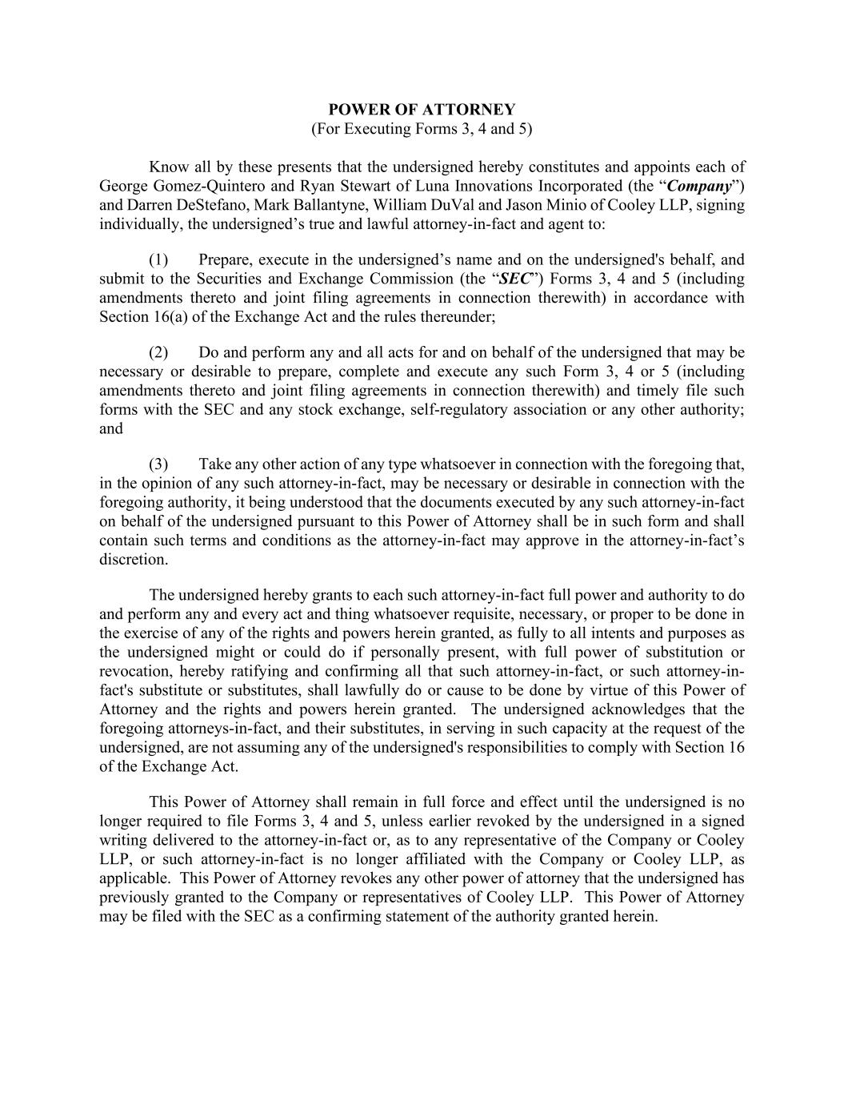
POWER OF ATTORNEY (For Executing Forms 3, 4 and 5) Know all by these presents that the undersigned hereby constitutes and appoints each of George Gomez-Quintero and Ryan Stewart of Luna Innovations Incorporated (the “Company”) and Darren DeStefano, Mark Ballantyne, William DuVal and Jason Minio of Cooley LLP, signing individually, the undersigned’s true and lawful attorney-in-fact and agent to: (1) Prepare, execute in the undersigned’s name and on the undersigned's behalf, and submit to the Securities and Exchange Commission (the “SEC”) Forms 3, 4 and 5 (including amendments thereto and joint filing agreements in connection therewith) in accordance with Section 16(a) of the Exchange Act and the rules thereunder; (2) Do and perform any and all acts for and on behalf of the undersigned that may be necessary or desirable to prepare, complete and execute any such Form 3, 4 or 5 (including amendments thereto and joint filing agreements in connection therewith) and timely file such forms with the SEC and any stock exchange, self-regulatory association or any other authority; and (3) Take any other action of any type whatsoever in connection with the foregoing that, in the opinion of any such attorney-in-fact, may be necessary or desirable in connection with the foregoing authority, it being understood that the documents executed by any such attorney-in-fact on behalf of the undersigned pursuant to this Power of Attorney shall be in such form and shall contain such terms and conditions as the attorney-in-fact may approve in the attorney-in-fact’s discretion. The undersigned hereby grants to each such attorney-in-fact full power and authority to do and perform any and every act and thing whatsoever requisite, necessary, or proper to be done in the exercise of any of the rights and powers herein granted, as fully to all intents and purposes as the undersigned might or could do if personally present, with full power of substitution or revocation, hereby ratifying and confirming all that such attorney-in-fact, or such attorney-in- fact's substitute or substitutes, shall lawfully do or cause to be done by virtue of this Power of Attorney and the rights and powers herein granted. The undersigned acknowledges that the foregoing attorneys-in-fact, and their substitutes, in serving in such capacity at the request of the undersigned, are not assuming any of the undersigned's responsibilities to comply with Section 16 of the Exchange Act. This Power of Attorney shall remain in full force and effect until the undersigned is no longer required to file Forms 3, 4 and 5, unless earlier revoked by the undersigned in a signed writing delivered to the attorney-in-fact or, as to any representative of the Company or Cooley LLP, or such attorney-in-fact is no longer affiliated with the Company or Cooley LLP, as applicable. This Power of Attorney revokes any other power of attorney that the undersigned has previously granted to the Company or representatives of Cooley LLP. This Power of Attorney may be filed with the SEC as a confirming statement of the authority granted herein.

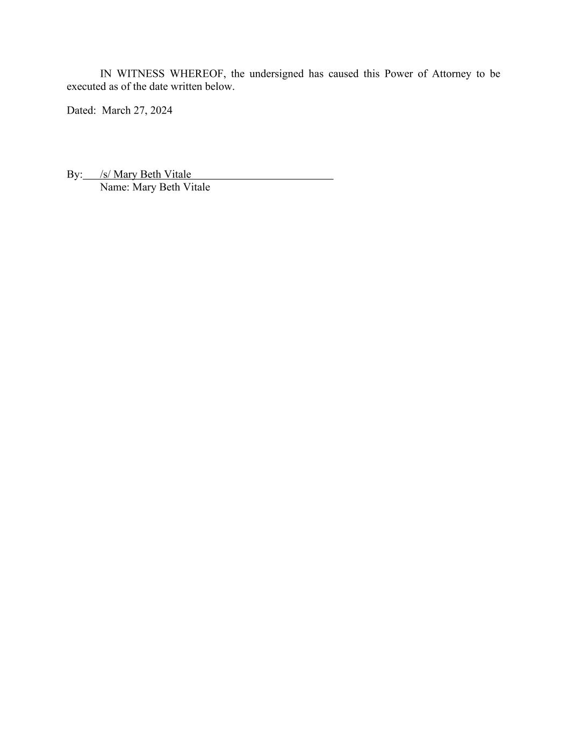
IN WITNESS WHEREOF, the undersigned has caused this Power of Attorney to be executed as of the date written below. Dated: March 27, 2024 By: /s/ Mary Beth Vitale Name: Mary Beth Vitale

