UNITED STATES
SECURITIES AND EXCHANGE COMMISSION
Washington, D.C. 20549
_____________________
FORM 8-K
_____________________
CURRENT REPORT
Pursuant to Section 13 or 15(d)
of the Securities Exchange Act of 1934
Date of Report (Date of earliest event reported): October 16, 2024
_____________________

LUNA INNOVATIONS INCORPORATED
(Exact name of registrant as specified in its charter)
_____________________

Delaware | 000-52008 | 54-1560050
(State or other jurisdiction | (Commission | (IRS Employer
of incorporation) | File Number) | Identification No.)
301 1st Street SW, | Suite 200 | 24011
Roanoke, | VA
(Address of principal executive offices) |  | (Zip Code)

Registrant’s telephone number, including area code: (540) 769-8400
N/A
(Former name or former address, if changed since last report.)
_____________________

Check the appropriate box below if the Form 8-K filing is intended to simultaneously satisfy the filing obligation of the registrant under any of the following provisions:

Written communications pursuant to Rule 425 under the Securities Act (17 CFR 230.425)

Soliciting material pursuant to Rule 14a-12 under the Exchange Act (17 CFR 240.14a-12)

Pre-commencement communications pursuant to Rule 14d-2(b) under the Exchange Act (17 CFR 240.14d-2(b))

Pre-commencement communications pursuant to Rule 13e-4(c) under the Exchange Act (17 CFR 240.13e-4(c))

Securities registered pursuant to Section 12(b) of the Act:

Title of each class |  | Trading |  | Name of each exchange
 |  | Symbol(s) |  | on which registered
Common Stock, $0.001 par value per share |  | LUNA |  | Nasdaq Stock Market, LLC

Indicate by check mark whether the registrant is an emerging growth company as defined in as defined in Rule 405 of the Securities Act of 1933 (§230.405 of this chapter) or Rule 12b-2 of the Securities Exchange Act of 1934 (§240.12b-2 of this chapter).

Emerging growth company

If an emerging growth company, indicate by check mark if the registrant has elected not to use the extended transition period for complying with any new or revised financial accounting standards provided pursuant to Section 13(a) of the Exchange Act.

Item 5.02 Departure of Directors or Certain Officers; Election of Directors; Appointment of Certain Officers; Compensatory Arrangements of Certain Officers.

Resignation of John C. Roiko as Chief Financial Officer

John C. Roiko, the Chief Financial Officer of Luna Innovations Incorporated (the “Company”), will retire from his position, effective October 16, 2024. Mr. Roiko expressed his desire to return to retirement after assisting the Company since May 2024. Mr. Roiko will continue to provide consulting services to the company to support the ongoing restatement processes. Mr. Roiko’s resignation is not the result of any disagreement with the Company on any matter relating to the Company’s operations, policies or practices. In connection with his resignation and retirement, Mr. Roiko did not receive any severance or other benefits based on his separation from the Company.

Appointment of William L. Phelan as Chief Financial Officer and Chief Accounting Officer

Effective October 16, 2024, the Board appointed William L. Phelan as the Company’s Chief Financial Officer and Chief Accounting Officer, in which capacity he will serve as the Company’s principal financial and accounting officer.

William L. Phelan, age 54, has served as a full-time consultant to the Company since May 2024, providing assistance and support with respect to corporate controller functions. Prior to his engagement by the Company, Mr. Phelan served as Chief Accounting Officer of MiMedx Group, Inc. from 2020 to 2023. Prior to that, he served as a Managing Director of CFGI, a firm providing accounting, reporting, tax and compliance services. Prior to CFGI, he served in a number of capacities, most recently as Chief Accounting Officer at Sancilio Pharmaceuticals Company, Inc. from 2015 to 2017. Mr. Phelan holds an MBA from Penn State University and a BSBA in Accounting from Shippensburg University of Pennsylvania.

In connection with Mr. Phelan’s appointment, the Company and Mr. Phelan entered into an offer letter (the “Offer Letter”), effective as of October 14, 2024. Pursuant to the Offer Letter, Mr. Phelan will be employed by the Company on an “at-will” basis, meaning either party may terminate the employment at any time, with or without cause or advanced notice. Mr. Phelan’s initial annual base salary will be $400,000 per year, subject to review and adjustment from time to time in the discretion of the Board. Pursuant to the Offer Letter, on October 16, 2024, the Company granted Mr. Phelan 150,000 restricted stock units (the “RSU Award”) pursuant to the Luna Innovations Incorporated 2024 Inducement Plan (the “Inducement Plan”). The RSU Award is subject to the terms of the Inducement Plan and a restricted stock unit award agreement by and between the Company and Mr. Phelan. 100% of the RSUs will vest upon the twelve (12) month anniversary of the date of grant. The RSU Award will accelerate in full upon a sale or the acquisition of substantially all of the assets or outstanding equity securities of the Company by a third party.

There is no arrangement or understanding between Mr. Phelan and any other person pursuant to which he was selected as an officer of the Company, and there is no family relationship between Mr. Phelan and any of the Company’s other directors or executive officers.

The foregoing description of the Offer Letter does not purport to be complete and is qualified in its entirety by reference to the full text of the Offer Letter, which is filed herewith as Exhibit 10.1, and incorporated herein by reference.

Item 7.01 Regulation FD Disclosure.

A press release dated October 16, 2024, disclosing the matters set forth above, is attached hereto as Exhibit 99.4.

The information furnished in this Item 7.01 of this Current Report on Form 8-K (including Exhibit 99.4 attached hereto) shall not be deemed “filed” for purposes of Section 18 of the Securities Exchange Act of 1934, as amended, and shall not be incorporated by reference into any filing of the Company under the Securities Act of 1933, as amended, except as shall be expressly set forth by specific reference in such filing.

Item 9.01 Financial Statements and Exhibits.

(d) Exhibits.

Exhibit |  |  | Description
10.1 |  |  | Offer Letter, effective as of October 14, 2024, by and between the Company and William L. Phelan
99.4 |  |  | Press Release dated October 16, 2024
104 |  |  | Cover Page Interactive Data File (embedded within the Inline XBRL document)

SIGNATURES

Pursuant to the requirements of the Securities Exchange Act of 1934, the registrant has duly caused this report to be signed on its behalf by the undersigned hereunto duly authorized.

Luna Innovations Incorporated

By: /s/ Ryan Stewart
Name: Ryan Stewart

Title: SVP, General Counsel and Corporate Secretary

Date: October 16, 2024

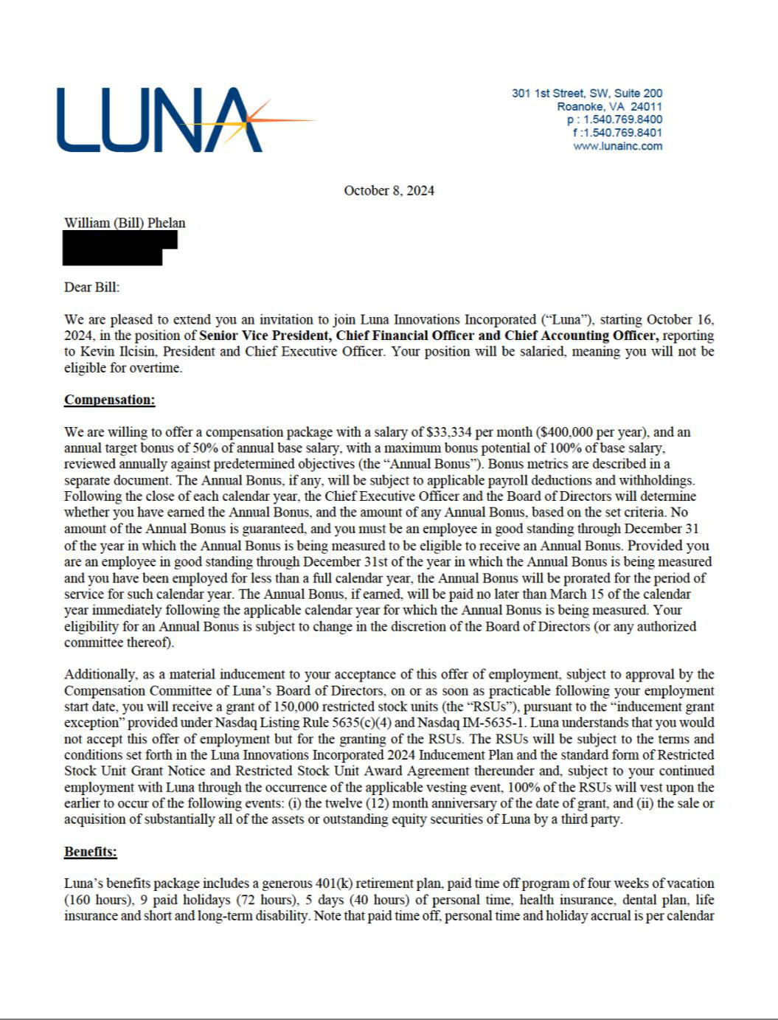

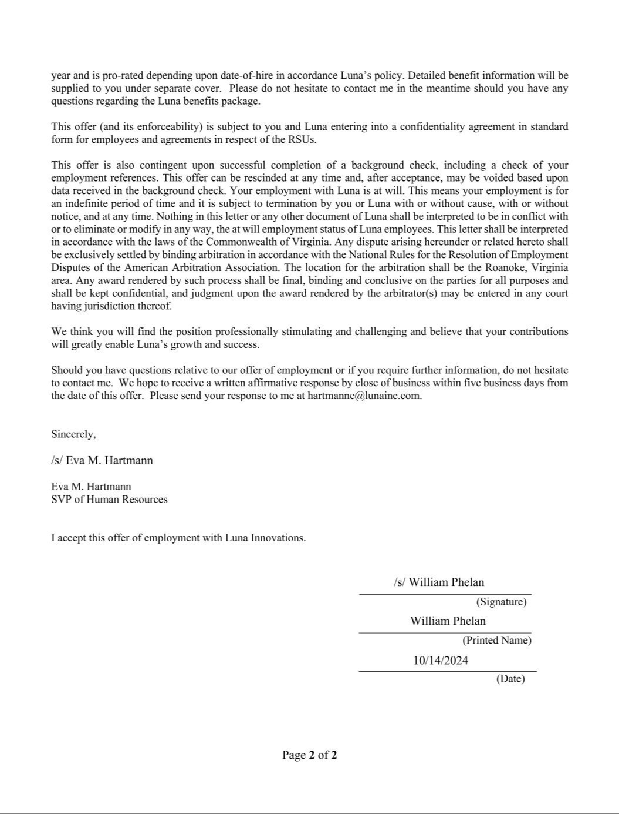


Luna Innovatons Announces CFO Transiton: Names
William Phelan as Chief Financial Ofcer and Chief Accountng Ofcer

(ROANOKE, VA, October 16, 2024) – Luna Innovatons Incorporated (NASDAQ: LUNA), a global leader in advanced fber optc-based technology, today announced the appointment of William L. Phelan as its new Chief Financial Ofcer and Chief Accountng Ofcer, efectve immediately. Mr. Phelan succeeds John Roiko, who joined Luna out of retrement in May 2024 and played a key role in establishing a resilient foundaton for Luna’s future growth. Following the appointment of Mr. Phelan, Mr. Roiko will shif to a consultng role to support the ongoing restatement process.

“We are delighted to welcome Bill to the Luna leadership team,” said Kevin Ilcisin, President and CEO of Luna. “Bill’s highly relevant experience will be instrumental as we contnue to execute our growth strategy in the global market for fber optc technology. We extend our heartelt thanks to John for his critcal contributons during a pivotal tme for the company. We are grateful for his leadership and are pleased he will contnue to ofer his support in a consultng capacity.”

Mr. Phelan brings more than 25 years of extensive fnancial and accountng leadership experience across multple industries. In his new role at the company, Mr. Phelan will oversee fnancial strategy, accountng operatons, and associated regulatory compliance, while playing a key role in driving the company’s fnancial and strategic growth. Mr. Phelan has been a full-tme advisor to the company since May 2024, providing him with in-depth knowledge of the company’s operatons and positoning him to immediately contribute to Luna’s success.

“I am excited to join Luna at this important juncture and contnue the work that John started,” said Phelan. “Luna has a tremendous opportunity to capitalize on its unique positon in the market, and I look forward to collaboratng with our talented team to drive both operatonal and fnancial excellence.”

Prior to his engagement by the company, Mr. Phelan served as Chief Accountng Ofcer at MiMedx Group, Inc., where he led the company's fnancial restructuring, SEC compliance and internal controls. His career includes leadership roles in fnancial planning, technical accountng, and regulatory reportng, having worked with both public and private companies to strengthen governance and optmize fnancial performance. Mr. Phelan holds a Master of Business Administraton from Pennsylvania State University and a Bachelor of Science in Business Administraton, Accountng, from Shippensburg University. He is a Certfed Public Accountant in Pennsylvania.

About Luna

Luna Innovatons Incorporated (www.lunainc.com) is a leader in optcal technology, providing unique capabilites in high-performance, fber optc-based, test products for the telecommunicatons industry and distributed fber optc-based sensing for a multtude of industries. Luna’s business model is designed to accelerate the process of bringing new and innovatve technologies to market.

Forward-Looking Statements

This press release contains statements that consttute “forward looking informaton” and “forward-looking statements” within the meaning of U.S. securites laws. All statements other than statements of historical facts contained in this press release, including statements regarding Mr. Phelan’s assumpton of the positon of Chief Financial Ofcer and Chief Accountng Ofcer and the company’s future performance are forward-looking statements. Forward-looking statements are based on management’s beliefs and assumptons and on informaton currently available to management. Such statements are subject to risks and uncertaintes, and actual results may difer materially from those expressed or implied in the forward-looking statements, including the uncertaintes inherent in management transitons and such other risks and uncertaintes described in the company’s flings with the U.S. Securites and Exchange Commission. Such flings are available on the SEC’s website at www.sec.gov and on Luna’s website at www.lunainc.com. The Company expressly disclaims any obligaton or undertaking to update the forward-looking statements contained in this press release to refect any change in its expectatons or any change in events, conditons, or circumstances on which such statements are based unless required to do so by applicable law. No assurance can be given that such future results will be achieved. Forward-looking statements speak only as of the date of this press release.

Investor Contacts

Allison Woody
Luna Innovatons Incorporated
Phone: 540.769.8465
Email: woodya@lunainc.com

###

