SEC Form 4

FORM 4

Check this box if no longer subject to Section
- Form 4 or Form 5 obligations may continue. See Instruction 1(b).

UNITED STATES SECURITIES AND EXCHANGE COMMISSION
Washington, D.C. 20549
Washington, D.C. 20549 |  | OMB APPROVAL
STATEMENT OF CHANGES IN BENEFICIAL OWNERSHIP
STATEMENT OF CHANGES IN BENEFICIAL OWNERSHIP |  | OMB Number: | 3235-0287
 |  | Estimated average burden
Filed pursuant to Section 16(a) of the Securities Exchange Act of 1934 |  | hours per response: | 0.5
or Section 30(h) of the Investment Company Act of 1940
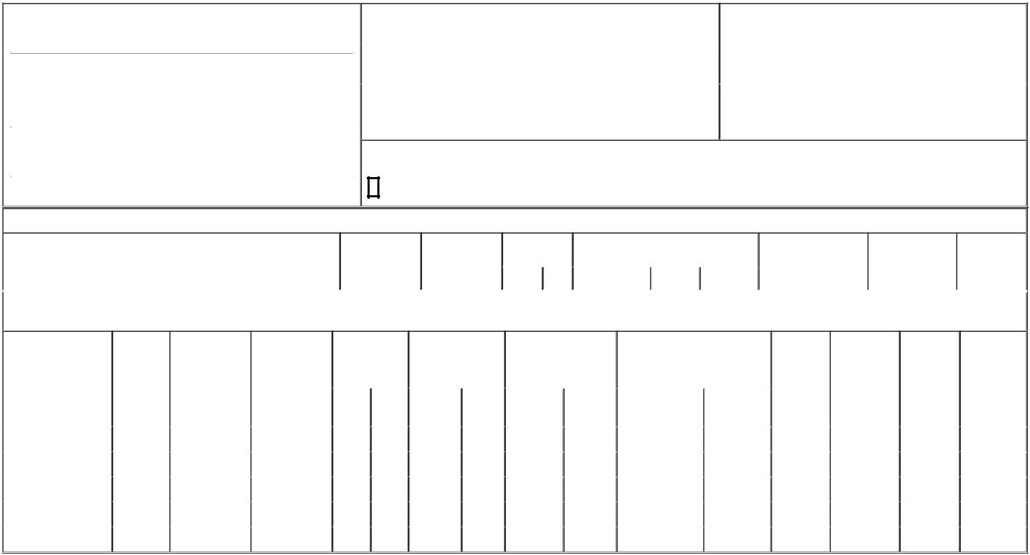

1. Name and Address of Reporting Person*
PHELPS BARRY

 | (Last) | (First) | (Middle)
 | C/O LUNA INNOVATIONS INCORPORATED
 | 301 1ST STREET SW, SUITE 200
(Street)
 | ROANOKE | VA | 24011
 | (City) | (State) | (Zip)

2. |  | Issuer Name and Ticker or Trading Symbol |  | 5. Relationship of Reporting Person(s) to Issuer
 | LUNA INNOVATIONS INC [ LUNA ] |  |  | (Check all applicable)
 |  |  |  | X | Director | 10% Owner
3. |  | Date of Earliest Transaction (Month/Day/Year) |  |  | Officer (give title | Other (specify below)
04/01/2024 |  |  |  |  | below) | Other (specify below)
4. |  | If Amendment, Date of Original Filed (Month/Day/Year) |  | 6. Individual or Joint/Group Filing (Check Applicable Line)
 |  |  |  | X | Form filed by One Reporting Person
 |  |  |  |  | Form filed by More than One Reporting Person

Rule 10b5-1(c) Transaction Indication

Check this box to indicate that a transaction was made pursuant to a contract, instruction or written plan that is intended to satisfy the affirmative defense conditions of Rule 10b5-1(c). See Instruction 10.

Table I - Non-Derivative Securities Acquired, Disposed of, or Beneficially Owned

 | 1. Title of Security (Instr. 3) | 2. Transaction | 2A. Deemed | 3. Transaction |  | 4. Securities Acquired (A) or Disposed Of |  | 5. Amount of Securities | 6. Ownership | 7. Nature of
 |  | Date | Execution Date, | Code (Instr. 8) |  | (D) (Instr. 3, 4 and 5) |  | Beneficially Owned | Form: Direct (D) or | Indirect
 |  | (Month/Day/Year) | if any |  |  |  |  | Following Reported | Indirect (I) (Instr. 4) | Beneficial
 |  |  | (Month/Day/Year) | Code | V | Amount | (A) or (D) Price | Transaction(s) (Instr. 3 |  | Ownership
 |  |  |  |  |  |  |  | and 4) |  | (Instr. 4)

Table II - Derivative Securities Acquired, Disposed of, or Beneficially Owned

(e.g., puts, calls, warrants, options, convertible securities)

1. Title of Derivative | 2. | 3. Transaction | 3A. Deemed | 4. Transaction |  | 5. Number of |  | 6. Date Exercisable and |  | 7. Title and Amount of Securities |  | 8. Price of | 9. Number of | 10. | 11. Nature of
Security (Instr. 3) | Conversion | Date | Execution Date, | Code (Instr. 8) |  | Derivative Securities |  | Expiration Date |  | Underlying Derivative Security |  | Derivative | derivative | Ownership | Indirect
 | or Exercise | (Month/Day/Year) | if any |  |  | Acquired (A) or |  | (Month/Day/Year) |  | (Instr. 3 and 4) |  | Security | Securities | Form: | Beneficial
 | Price of |  | (Month/Day/Year) |  |  | Disposed of (D) |  |  |  |  |  | (Instr. 5) | Beneficially | Direct (D) or | Ownership
 | Derivative |  |  |  |  | (Instr. 3, 4 and 5) |  |  |  |  |  |  | Owned | Indirect (I) | (Instr. 4)
 | Security |  |  |  |  |  |  |  |  |  |  |  | Following | (Instr. 4)
 |  |  |  |  |  |  |  |  |  |  | Amount or |  | Reported
 |  |  |  |  |  |  |  | Date | Expiration |  | Number of |  | Transaction(s)
 |  |  |  | Code | V | (A) | (D) | Exercisable | Date | Title | Shares |  | (Instr. 4)
Stock Units | (1) | 04/01/2024 |  | A |  | 3,465.35⁽²⁾ |  | (3) | (3) | Common Stock | 3,465.35 | $0 | 113,314.51 | D
Stock Units | (1) | 04/01/2024 |  | A |  | 1,237.62⁽⁴⁾ |  | (3) | (3) | Common Stock | 1,237.62 | $0 | 114,552.13 | D
Stock Units | (1) | 04/01/2024 |  | A |  | 907.59⁽⁵⁾ |  | (3) | (3) | Common Stock | 907.59 | $0 | 115,459.72 | D
Stock Units | (1) | 04/01/2024 |  | A |  | 412.54⁽⁶⁾ |  | (3) | (3) | Common Stock | 412.54 | $0 | 115,872.26 | D
Stock Units | (1) | 04/01/2024 |  | A |  | 412.54⁽⁷⁾ |  | (3) | (3) | Common Stock | 412.54 | $0 | 116,284.8 | D

Explanation of Responses:

- Stock Units are convertible into issuer's common stock on a 1-for-1 basis.

- This grant was made pursuant to the issuer's non-employee director compensation policy, as compensation for Mr. Phelps's service as a member of the board of directors for the period from April 1, 2024 to June 30, 2024. The number of restricted stock units is equal to $10,500.00 divided by $3.03, the closing price of the issuer's common stock on the Nasdaq Capital Market on April 1, 2024, the first trading day of the quarter. The Reporting Person elected to receive fees in stock units.

- The stock units become issuable in common stock of the issuer at the election of the Reporting Person upon the earliest to occur of the Reporting Person's termination of service, a change in control of the issuer, an unforeseeable emergency, or a fixed selected by the Reporting Person. The units have no expiration date.

- This grant was made pursuant to issuer's non-employee director compensation policy, as compensation for Mr. Phelps's service as the chairman of the audit committee of the board of directors for the period from April 1, 2024 to June 30, 2024. The number of restricted stock units is equal to $3,750.00 divided by $3.03, the closing price of issuer's common stock on the Nasdaq Capital Market on April 1, 2024, the first trading day of the quarter. The Reporting Person elected to receive fees in stock units.

- This grant was made pursuant to issuer's non-employee director compensation policy, as compensation for Mr. Phelps's service as the chairman of the operations committee of the board of directors for the period from April 1, 2024 to June 30, 2024. The number of restricted stock units is equal to $2,750.00 divided by $3.03, the closing price of issuer's common stock on the Nasdaq Capital Market on April 1, 2024, the first trading day of the quarter. The Reporting Person elected to receive fees in stock units.

- This grant was made pursuant to issuer's non-employee director compensation policy, as compensation for Mr. Phelps's service on the compensation committee of the board of directors for the period from April 1, 2024 to June 30, 2024. The number of restricted stock units is equal to $1,250.00 divided by $3.03, the closing price of issuer's common stock on the Nasdaq Capital Market on April 1, 2024, the first trading day of the quarter. The Reporting Person elected to receive fees in stock units.

- This grant was made pursuant to issuer's non-employee director compensation policy, as compensation for Mr. Phelps's service on the risk committee of the board of directors for the period from April 1, 2024 to June 30, 2024. The number of restricted stock units is equal to $1,250.00 divided by $3.03, the closing price of issuer's common stock on the Nasdaq Capital Market on April 1, 2024, the first trading day of the quarter. The Reporting Person elected to receive fees in stock units.

Remarks:

 | /s/ Ryan Stewart, Attorney-in-Fact |  |  | 04/03/2024
 | ** Signature of Reporting Person |  | Date
Reminder: Report on a separate line for each class of securities beneficially owned directly or indirectly.
* If the form is filed by more than one reporting person, see Instruction 4 (b)(v).
** Intentional misstatements or omissions of facts constitute Federal Criminal Violations See 18 U.S.C. 1001 and 15 U.S.C. 78ff(a).
Note: File three copies of this Form, one of which must be manually signed. If space is insufficient, see Instruction 6 for procedure.
Persons who respond to the collection of information contained in this form are not required to respond unless the form displays a currently valid OMB Number.



